**Institute of Computer Technology**

**B. Tech. Computer Science and Engineering**

**Sub: BOSS (2CSE204)**

**Practical -1**

**Objectives:** To learn about Accessing the Command Line in Linux.

**Commands:**

date-Description of Command

file-Description of Command

cat-Description of Command

less-Description of Command

head-Description of Command

passwd-Description of Command

tail-Description of Command

wc-Description of Command

**Exercise:**

**Jihan wants to perform following operations in terminal window using CLI. Kindly implement a appropriate commands for the given scenarios.**

1. He wants to display the current time and date on terminal window.

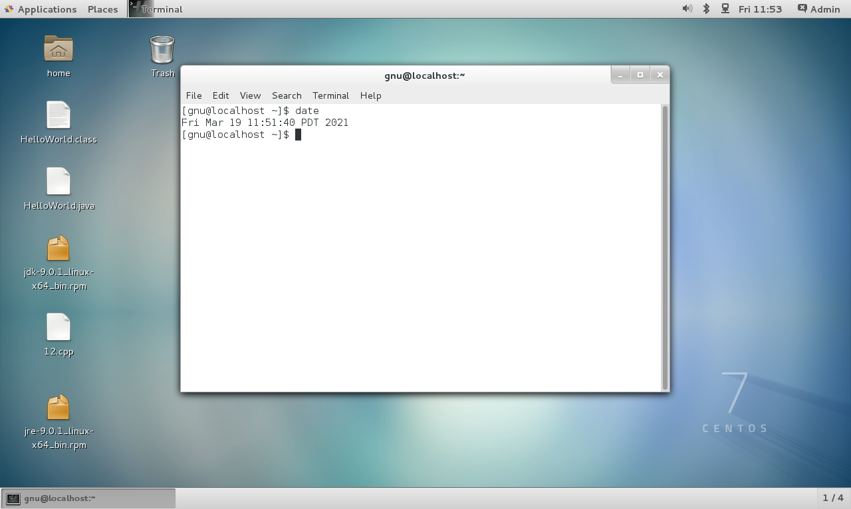

1. Display the current time in 12-hour clock time (for example, 11:42:11 AM). Hint: The format string that displays that output is %r.

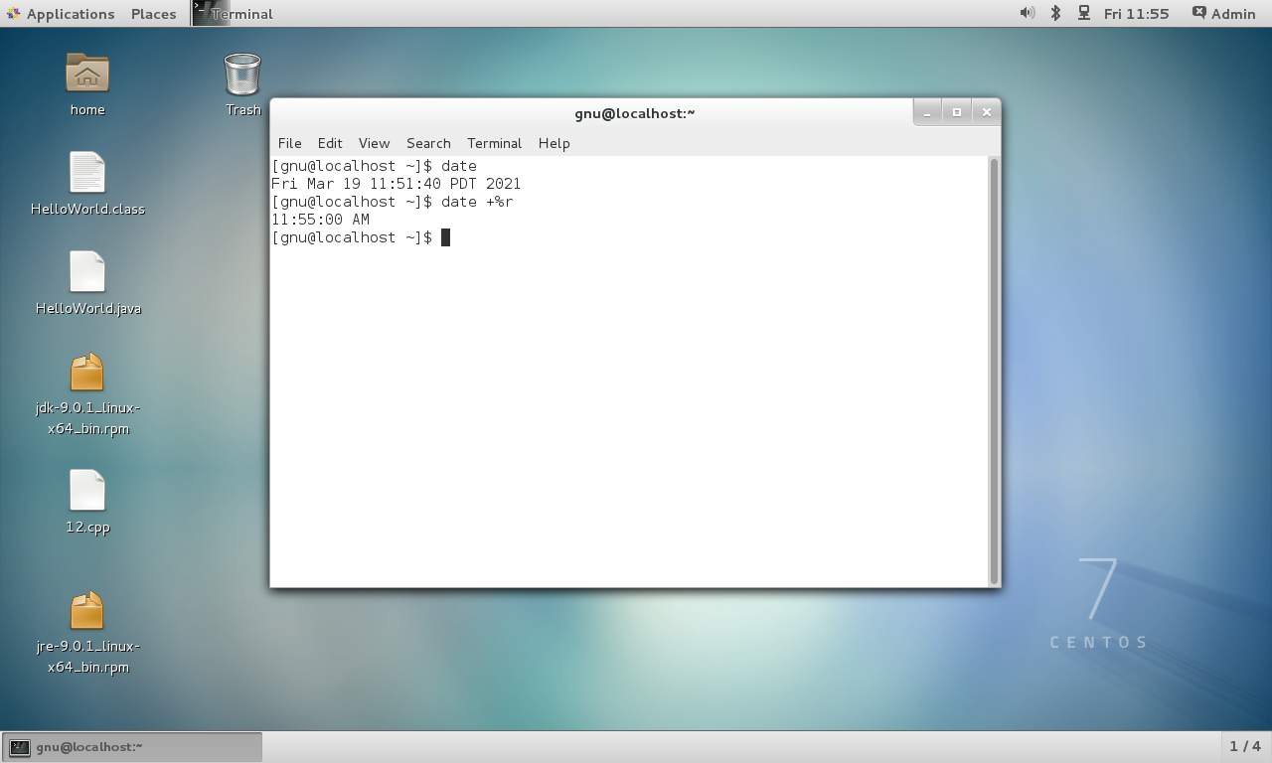

1. zcat is available file in system. Jihan wants to check that What kind of file is /home/student/zcat? Is it readable by humans? How will he check?

**Screenshot of given task**

1. He wants to display the size of zcat on terminal.

**Screenshot of given task**

1. He wants to display the first 10 lines of zcat.

**Screenshot of given task**

1. He wants to display the last 10 lines of the zcat file.

**Screenshot of given task**

1. Jihan wants to repeat the previous command using keystrokes.

**Screenshot of given task**

1. Now, He needs to display the last 20 lines in the file. Use command-line editing to accomplish this with a minimal number of keystrokes.

**Screenshot of given task**

1. He wants to run date +%r command again through shell history.

**Screenshot of given task**